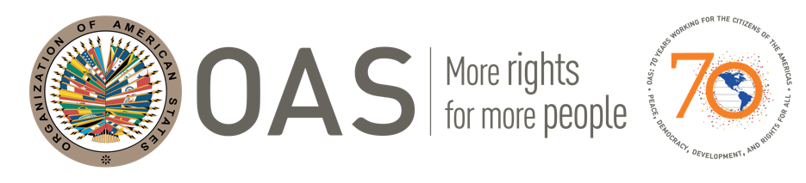

OAS: 70 years working for the citizens of the Americas
Peace, democracy, development, and rights for all

PROGRAM COMMEMORATING THE 70th ANNIVERSARY OF THE ORGANIZATION OF AMERICAN STATES

Hosts: OAS Country Office in Belize and OAS Adjacency Zone Office at Western Border
Date: Wednesday, 15 August, 2018
Time: 10:00 am
Place: Radisson Fort George Hotel and Marina

OPENING: Ms. Tisa Grant, OAS Belize Scholar, Liaison Officer of UNFPA and Mistress of Ceremonies

INVOCATION – The Rt. Rev. Phillip Wright, Anglican Bishop of Belize.

WELCOME: Mr. Starret D Greene, OAS Representative in Belize

CULTURAL ITEM - Participants in Culture of Peace Programme - OAS Adjacency Zone Office

MINISTRY OF FOREIGN AFFAIRS - Hon. Wilfred Elrington, Minister of Foreign Affairs
CEO H.E. Patrick Andrews, Ministry of Foreign Affairs

SUPREME COURT OF BELIZE - Chief Justice, H.E. Kenneth A. Benjamin

MINISTRY OF HUMAN DEVELOPMENT, SOCIAL TRANSFORMATION AND POVERTY ALLEVIATION
CEO Mrs. Judith Alpuche, MHDSTPA

CULTURAL ITEM - Participants in Culture of Peace Programme - OAS Adjacency Zone Office

OAS BELIZE SCHOLARS – (1) Mrs. Ralna Lewis, Assistant Country Director – Wildlife Conservation Society
(2) Mrs. Angeline Valentine Enriquez, Project Officer, Meso-America Reef Fund

BELIZE PORT AUTHORITY- Mrs. Merlene Bailey-Martinez - Commissioner of Ports

NATIONAL DRUG ABUSE CONTROL COUNCIL – Mr. Esner Vellos, Director

CULTURAL ITEM - Participants in Culture of Peace Programme - OAS Adjacency Zone Office

UNICEF – Dr. Susan Kasedde – Country Representative for UNICEF in Belize

BELTRAIDE - Mrs. Nilda Riverol, Manager, SBDC Belize - a Unit of BELTRAIDE

OAS ADJACENCY ZONE – Mrs. Isis Morales, Staff - OAS Adjacency Zone Office

CULTURAL ITEM - Participants in Culture of Peace Programme - OAS Adjacency Zone Office

CLOSING – Mr. Starret D Greene, OAS Representative in Belize

LUNCH is served

